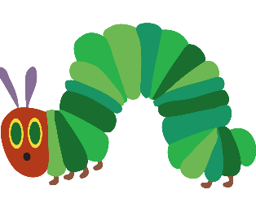

The Very Hungry Caterpillar Activities:

1. Practise saying and writing the days of the week.
2. Make a caterpillar using a repeating pattern of 2/3 colours or 2/3 shapes.
3. The classic butterfly making using paint etc – symmetry.
4. Find out about the life cycle of butterflies.
5. Can you write your own version of the hungry…… choose another mini-beast.
6. Can you look on-line and find out and read other stories by Eric Carle?

