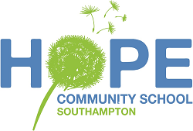 Hope Community School Menu

Week 3

Monday: | Hot Dog in a Bun with Mixed Salad  (V) Vegetarian Sausage  Fruit Salad
Tuesday: | Pasta with Meatballs in an Italian Tomato Sauce and Vegetables  (V) Veggie Balls  Chocolate Tray Bake
Wednesday: | Chicken and Salad Wraps with Cous Cous  (V) Quorn Salad Wraps  Yoghurt and Fruit Pots
Thursday: | Meatloaf with Cauliflower Cheese and Green Beans  (V) Quorn Meatloaf  Jam Cup Cakes
Friday: | Cod Cakes with Oven Fries and Baked Beans  (V) Veggie Cakes Available  Vanilla Ice Cream with Banana  (Dairy Free Ice Cream Available)

