17th March 2020

Re. Covid-19

Dear Parents,

With the situation changing rapidly I am writing to update you with some further information about Covid-19 and the school’s response.

As you may know the national guidance changed yesterday which is as follows:

Stay at home if you have either:

A high temperature – you feel hot to touch on your chest or back
A new, continuous cough – this means you've started coughing repeatedly
Do not go to a GP surgery, pharmacy or hospital.

You do not need to contact 111 to tell them you're staying at home.

Testing for coronavirus is not needed if you're staying at home.

How long to stay at home:
As a family if anyone has the symptoms mentioned above, you should all stay at home for 14 days from the day the first person got symptoms
If you live with someone who is 70 or over, has a long-term condition, is pregnant or has a weakened immune system, try to find somewhere else for them to stay for 14 days.
If you have to stay at home together, try to keep away from each other as much as possible.

I mentioned in my letter yesterday that we are stopping parents coming into classrooms during soft starts and ends; enforcing hand washing; and making parents evenings telephone consultations as a response the Covid-19. We are also now:

- Cancelling school trips until further notice;
-Postponing lovely hat collective until further notice;
-Postponing Dance Club until further notice;
-Postponing coffee mornings until further notice.
- limiting use of some resources in early years including sand, water and playdough.

As you may know schools are to remain open where possible for the time being but we are planning to ensure children will have work to do if the school is forced to close and plans are afoot to help families if they are stuck without a support network.

As you can imagine, with the new guidance we may find ourselves in a situation where we are unable to open a year group or even the school due to staff shortage. We will approach this like we would approach a ‘snow day’ and try to inform people through emails, our facebook page and website.

I will continue to update you and please do contact the school if you need any further support or advice.

Yours sincerely,
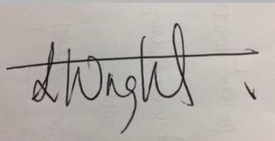
Mr. Wright

(Principal, Hope Community School Southampton)

