2nd July 2019

Dear Parents,

End of term is fast approaching and at this busy time of year I am writing to confirm some important dates.

Wednesday 3rd July – Transition morning - Children will meet their new class teachers. During the soft start Pioneer parents can say hello to our new member of staff and Y2 teacher Miss Hill.

Thursday 4th July – Opportunity for Explorer parents to meet Mrs. Woodman. Mrs Woodman will be available at the end of the day to meet any Explorer parents who would like to introduce themselves.

Wednesday 10th July – Sports Afternoon – City College have kindly allowed us to use their hall to host our annual sports afternoon. The event will take place between 13.30 and 14.30 and parents are invited to come along and cheer their children along! If you would like to join us please come to the Chapel Road entrance to City College at 13.30 where you will be greeted by Mr Wright and escorted to the correct location. If you can come and watch you are invited to take your children home directly from City College. If you are unable to attend we will take children back to school and you will be able to pick up at the normal time.

Friday 12th July – End of Year Reports – Parents are invited to come into school in the afternoon to share their child’s work and receive their end of year report. Explorer parents can come in from 14.30 and Pioneer parents can come in from 15.00.

Friday 19th July – End of Year collective – You are invited to attend our final Lovely Hat assembly of the year during which we will celebrate the achievements of the year.

Tuesday 23rd July – Final day of term – Finish at 13.30. We would like to invite all parents to come and join us for a `Bring and Share Lunch’ from 12:00. We can all enjoy lunch together and celebrate the end of the academic year.

Yours sincerely,
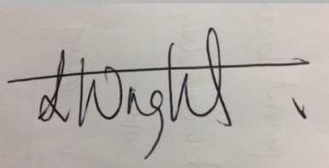
Mr Wright
(Principal, Hope Community School Southampton)

